***212 Warriors Compete at IHSA State Championships***

On May 24th Friday and May 25th Saturday the 212 Warriors competed at the 2013 IHSA State Championships. The Warriors were coming off an awesome 3 week stretch of meets at County, Conference, and Sectionals where the team was setting huge personal bests, All Time Top 10 marks, school records, and winning Conference titles. When that happens a coach always wonders if the team can keep that kind of energy moving towards possible State medals. The State meet demands so much mental toughness and simply does not reward the best that got there it rewards those who are the BEST on those two days. No meet represents that “seeds mean nothing” more than the State meet does. It simply is a meet where athletes can stay at the top, or grind out a medal, or feel the pressure, or come out of nowhere and bust huge times and marks. The DHS Track & Field program has been on both sides of all those scenarios and seen State meets where we almost bring home a State trophy, almost win State titles in individual events, grind out the 9th place medal out of nowhere, and State Meets where frustration, heartbreak, and disappointment rule the day.

Unfortunately this year was the ladder for the 2013 Team. The Warriors came in with a real shot at making finals in all their events, and placing in some, but we never seemed to catch good energy and confidence and we seemed to just grind and could not get a good rhythm. We just didn’t look like ourselves from the minute we got into our events. I will say that seemed to be the case across the meet as well as many kids just looked uncomfortable in many events and that may have been due to the erratic spring the state had with weather and meet cancellations. Simply put this years State meet was wide open for anyone and that rang true as there were a ton of “upsets” on the track and in the field.

The boys really gave great great effort and competed with passion but in the end the Warriors came home with SOLID performances, competed hard, and I truly believe they left it all on the Track and in the Field for the 212.

Dominic Dibenedetto finished 24th in the Shot to earn 3rd Team All-State honors and as a Junior gained valuable State Meet experience as he struggled with the new rings that were installed as did the entire State. Dominic really grinded the best he could but just couldn’t get balance and grip and slided and slipped his way to the best throws he could. What was exciting was how much passion and care he showed after his event. He wants to be a great one and that showed. We will be looking to him to be a foundation for the 2014 DHS Throws Force and 2014 Team. Dominic finished his year as CSL North Champ and 4th All Time at DHS In Shot Put…What a year!

Donald Middlebrook finished an legendary career at DHS as one of the best Track & Field athletes to ever come through the Deerfield Track & Field Program as he is 5th All Time in the 400, broke the 4x100, 4x200, and 4x400 Relay School Records and was one of the best vaulters as well with a PR of 13’9”

Donald finished tied for 13th in the State Meet in Pole Vault and literally left a piece of himself at the State meet as he blew his hamstring on his 1st attempt at the Finals Qualifying mark of 14’0”. The coaches were told he had been battling that injury for weeks but he didn’t say a word because he wanted to do all he could for the team…That is how tough this kid is! Great career Donald!

Alex Gold finished a legendary career as well as he is 5th All Time in the 3200m at DHS with a Nationals level qualifying time of 9:09.13, 10th All Time in the 1600m, All State in Cross Country, Conference Champion in the 3200m and 1600m, County Champion and Sectional Champion in the 3200m, and owns all of our DFDC Training Records. A young man that helped change Deerfield Distance Running forever and that was on display at the State meet as he said he wanted to win the State title so he took the race out and led the entire 1st mile and set the table for a very fast 2nd mile and a chance to race to win; however, he did not anticipate how the field dropped a 64 second 5th quarter after the mile and he just couldn’t respond to such a move as he stated “I’ve never seen or experienced a drop like that by so many runners at once” At the state level if you don’t respond immediately your race is over and that was the case for Alex. Looking back Alex has never held back or stayed in the back and if he was going down it was on his terms and what a gutsy approach to the biggest race on the biggest stage. Alex finished 11th with a solid time of 9:18 and earned 2nd Team All-State honors. Some perspective on what this time means. Alex was the 52nd best runner in the State in Cross Country overall when you add the 2A and 3A classes together he was the 14th overall in Track. That’s a huge improvement and jump made in one season. Hard work over time beats talent and Alex embodies that perfectly.

Alex Gold will always be a DFDC legend!

Great Job and Season Warriors! 212!

*Full meet results can be found at [www.ihsa.org](http://www.ihsa.org)

**212 Warriors at State Championships**

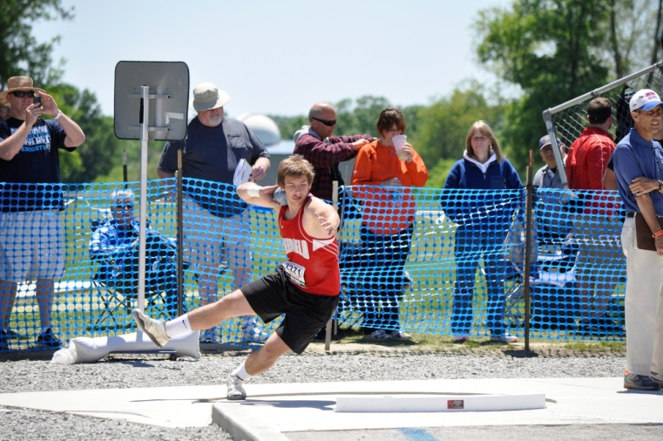

Dominic Dibenedetto-Shot Put- 24th 3rd Team All State

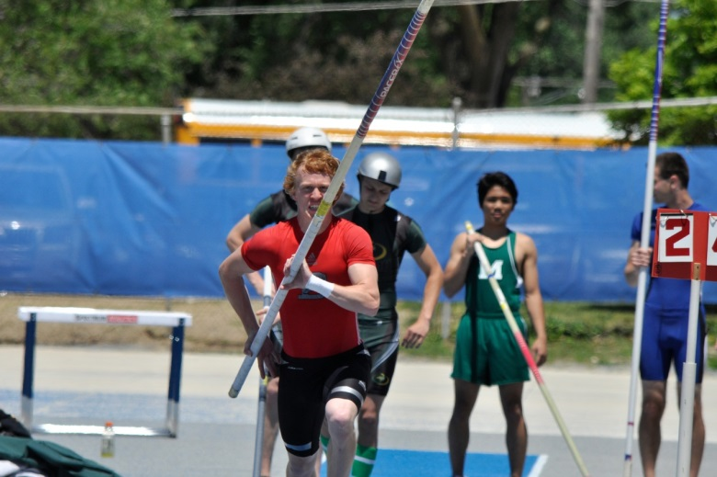

Donald Middlebrook-Pole Vault-13th-2nd Team All State

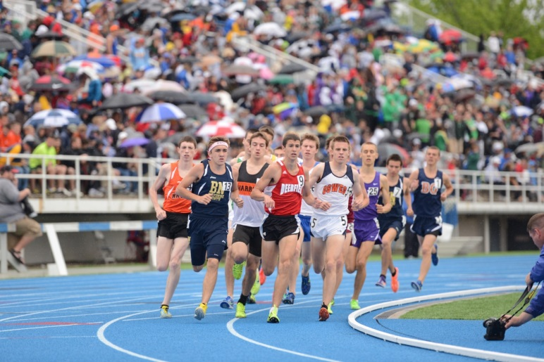

Alex Gold-3200m-11th-2nd Team All State